Name: ___________________________________ Date: ______________________ Period: _______

**Genotypes and Phenotypes**

**Use your vocabulary reference sheet to define the following prefixes and suffixes.**

What does ***homo*-** mean? _________________ What does ***hetero*-** mean? _________________

What does –***zygous*** mean? ______________________________________________________________

Define **homozygous**: ____________________________________________________________________

Define **heterozygous**: ___________________________________________________________________

**Mammal Traits**

**Plant Traits**



**Insect Traits**

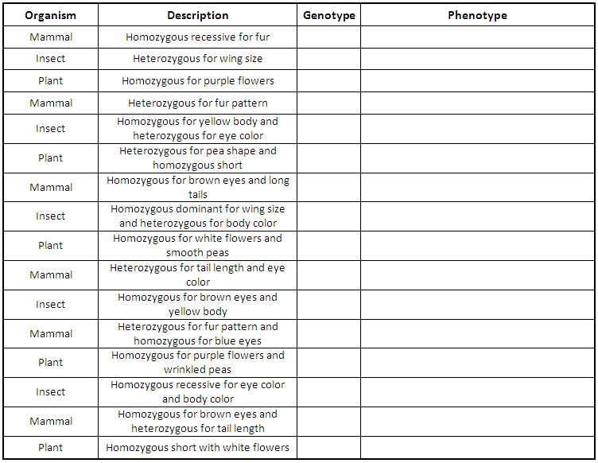

Decide which Punnett square represents both the parents and their offspring. Assume that the offspring shown represent the ratio expected from the Punnett square.

© Haney Science

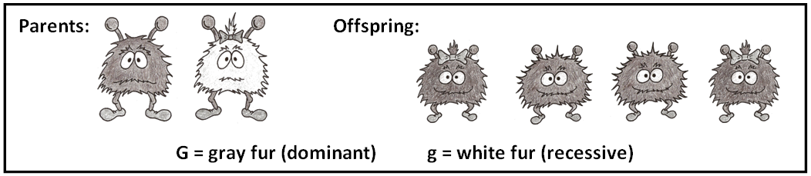

**GG**

**Gg**

**GG**

**Gg**

**G g**

**G**

**G**

**Gg**

**Gg**

**Gg**

**Gg**

**G G**

**g**

**g**

**GG**

**Gg**

**Gg**

**gg**

**G g**

**G**

**g**

**GG**

**GG**

**Gg**

**Gg**

**G G**

**G**

**g**

**B**

**D**

**C**

**A**

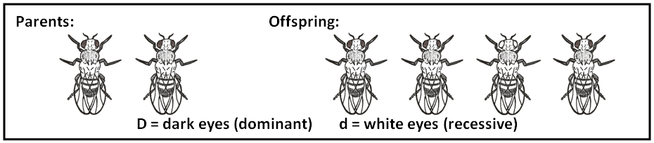

**G**

**F**

**Dd**

**Dd**

**Dd**

**Dd**

**D D**

**d**

**d**

**Dd**

**dd**

**Dd**

**dd**

**D d**

**d**

**d**

**DD**

**Dd**

**DD**

**Dd**

**D d**

**D**

**D**

**DD**

**Dd**

**Dd**

**dd**

**D d**

**D**

**d**

**H**

**J**

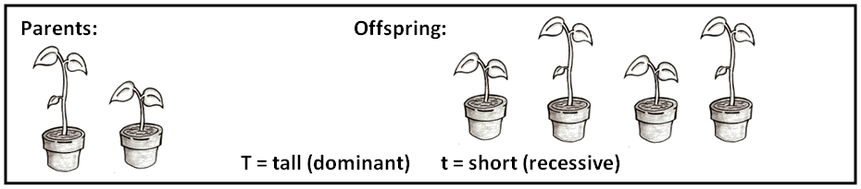

**A**

**Tt**

**tt**

**Tt**

**tt**

**T t**

**t**

**t**

**Tt**

**Tt**

**Tt**

**Tt**

**T T**

**t**

**t**

**TT**

**Tt**

**Tt**

**tt**

**T t**

**T**

**t**

**TT**

**TT**

**Tt**

**Tt**

**T T**

**T**

**t**

**B**

**C**

**D**